1. **Maven** is responsible to resolve the dependency described in pom.xml file with one of its **remote repositories**.
   1. **When** we specify the dependency, maven needs some place to retrieve that artifact for us.
2. **Repository**: Holds **plug-ins** & **dependency.**
3. **NOTE:** These repositories are remote 🡺 So we need protocol to access them (HTTP/HTTPS).
4. **Question:** How & Where the repository is specified?
   1. 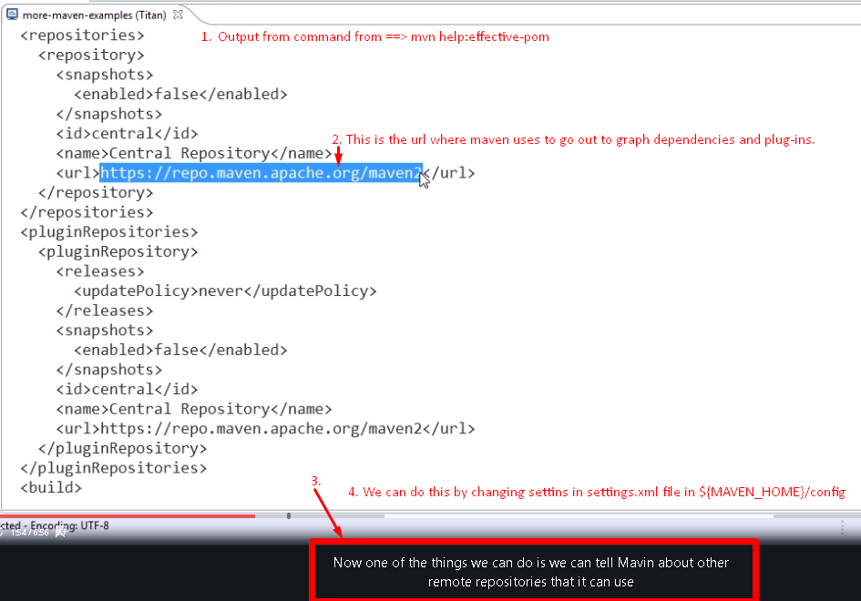
   2. Whatever, you change in the **${M2_HOME}/config/settings.xml**, the changes are reflected in all the maven instances referred by other users on the same machine.
   3. There is **${user. home}/.m2/settings.xml** (If not there, we can create)
   4. 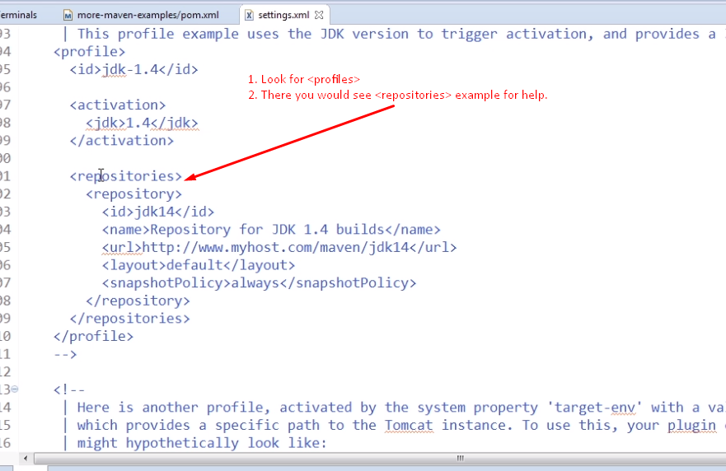
   5. 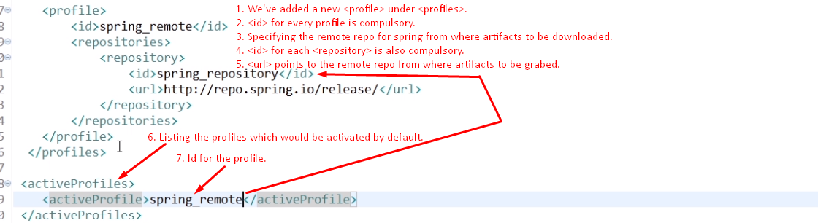
   6. Sometimes, you would not be able to find a specific artifact on maven central repo.
   7. **Reasons:**
      1. A specific version is not there on maven central repo.
      2. Artifact not loaded on there.
      3. Artifact is proprietary.   
         **For example**: Oracle has its own maven central which you need to authenticate with. Then you can access oracle libraries which are not published on maven central repo.